**ST. XAVIER’S COLLEGE**

**(Affiliated to Tribhuvan University)**

**Maitighar, Kathmandu**



**SIMULATION AND MODELING LAB REPORT #02**

**SUBMITTED BY:**

Pradeep Dahal

017BSCIT029

3rd year/ 5th Sem

|  |  |
| --- | --- |
|  | Signature |
| Mr. Ganesh Yogi  (Lecturer) |  |
| Department of Computer Science | |

**SUBMITTED TO:**

**TITLE: TO SIMULATE THE RANDOM WALK OF PARTICLES.**

**THEORY:**

A random walk is a fundamental physical process in which a random walker — a particle, an atom, a measurement, an individual — moves in random steps. A typical example is the Brownian motion of small particles due to the thermal motion of atoms. Another example is the spreading of an atom throughout a fluid.

**In one dimension,** we can describe a random walk by its random individual steps, UI, where i is the step number. The step ui is a random variable that may have some distribution. The position, x, of the walker after N steps is the sum of the individual steps:

x(N) = ∑ ui

**Random walks in two dimensions.** We can define random walks in any dimension, simply by assuming the individual steps can occur in any dimension. In two dimensions we may introduce u, which may for example be

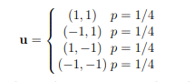

This simply corresponds to selecting one ui in the x-direction and and vi in the y-direction with the same distribution.

**Procedure**

**Step1:** Make table entries as in the figure below

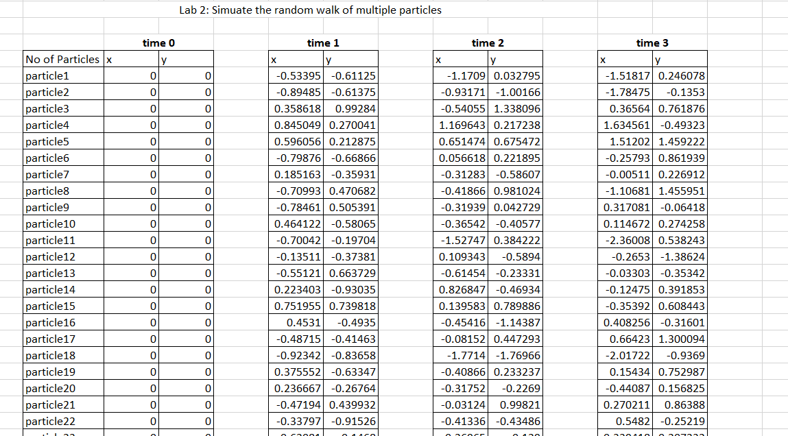

**Step2:** For Time0, take X and Y Co-ordinates as 0(Particles at rest)

**Step3**: For time-N, use

X =D4+ (1-2*RAND ( )); take previous X co-ordinate value

Y =E4+ (1-2*RAND ( )); take previous Y co-ordinate value

**Step4:** Plot graph for each Time

**CONCLUSION**

Hence, the random walk of particles was simulated using EXCEL